**Week 3**

**Interviewing**

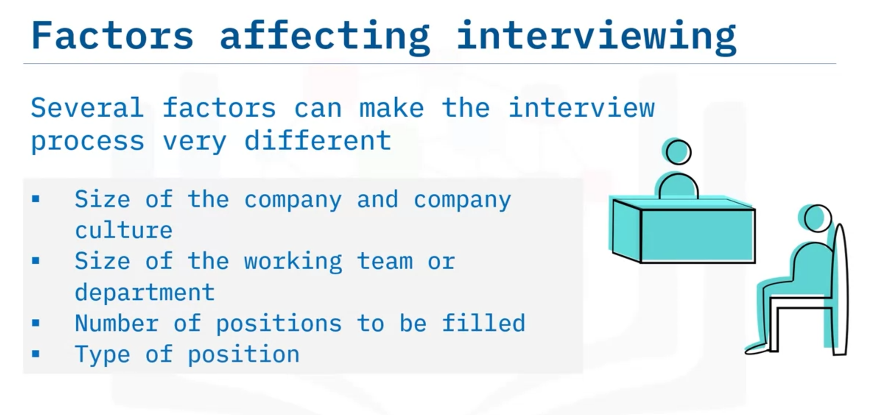

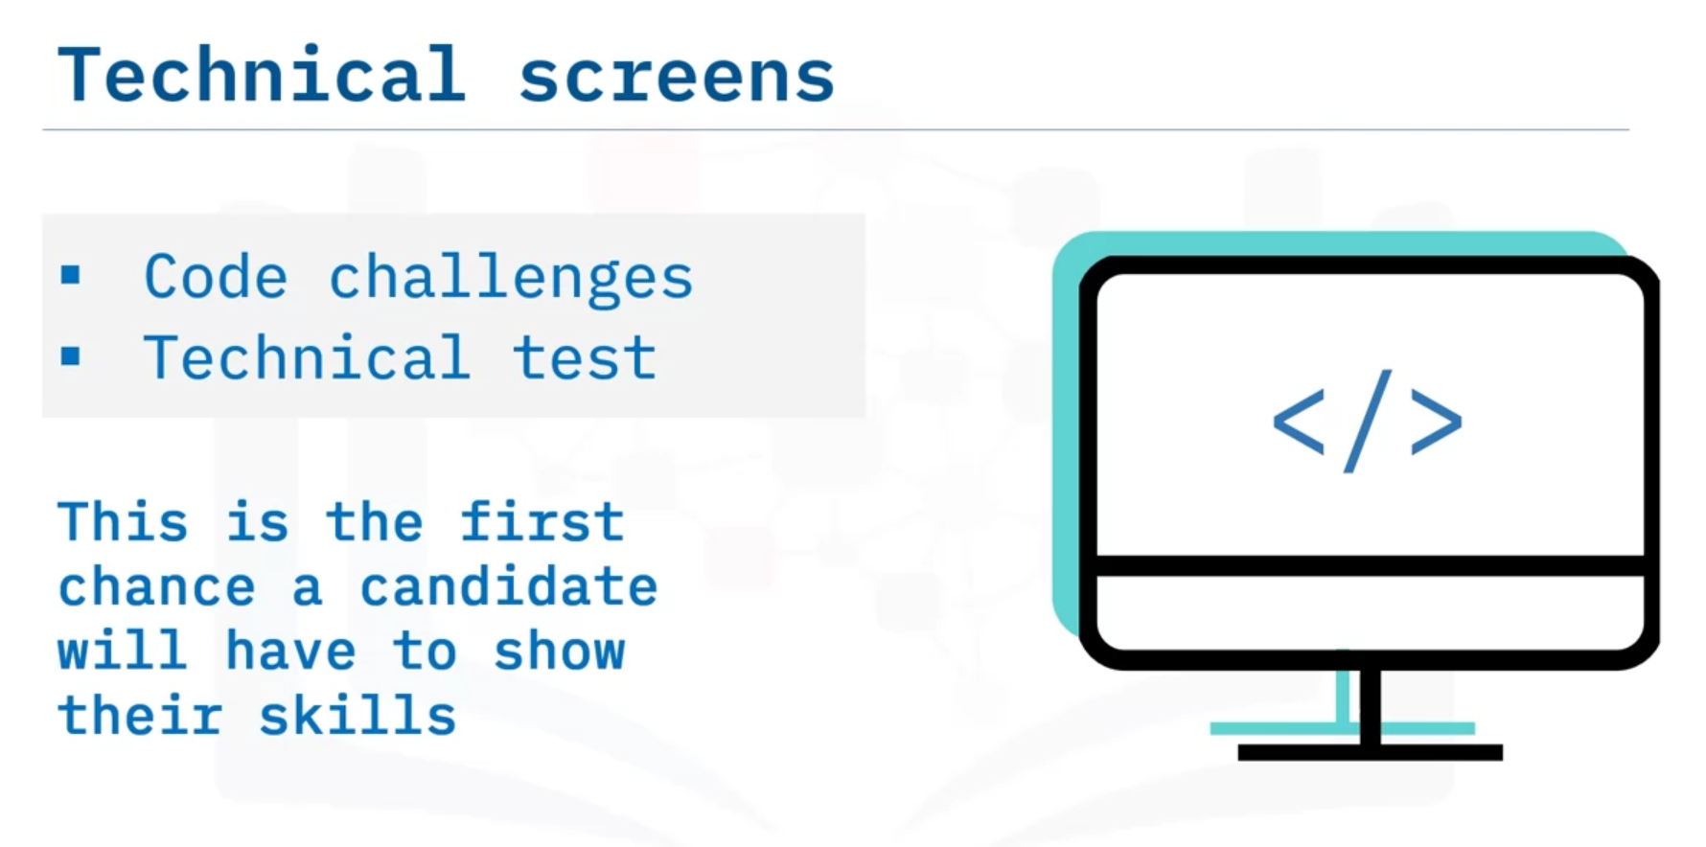

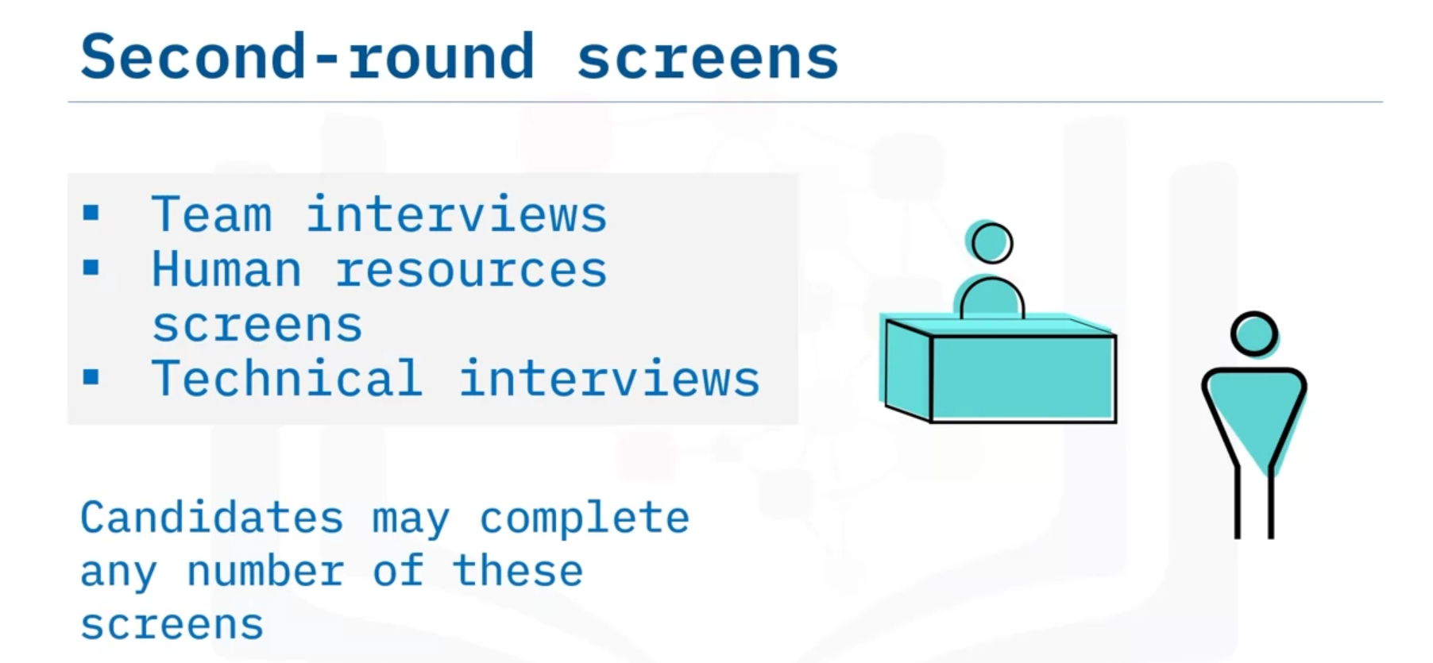

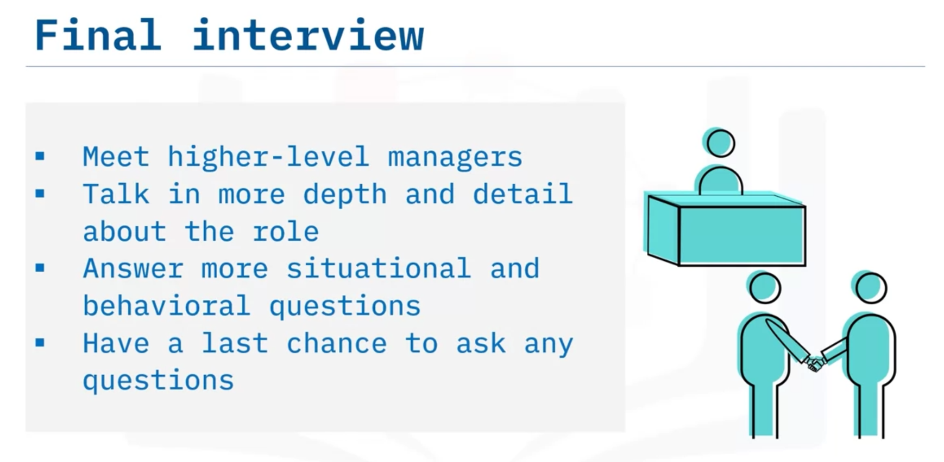

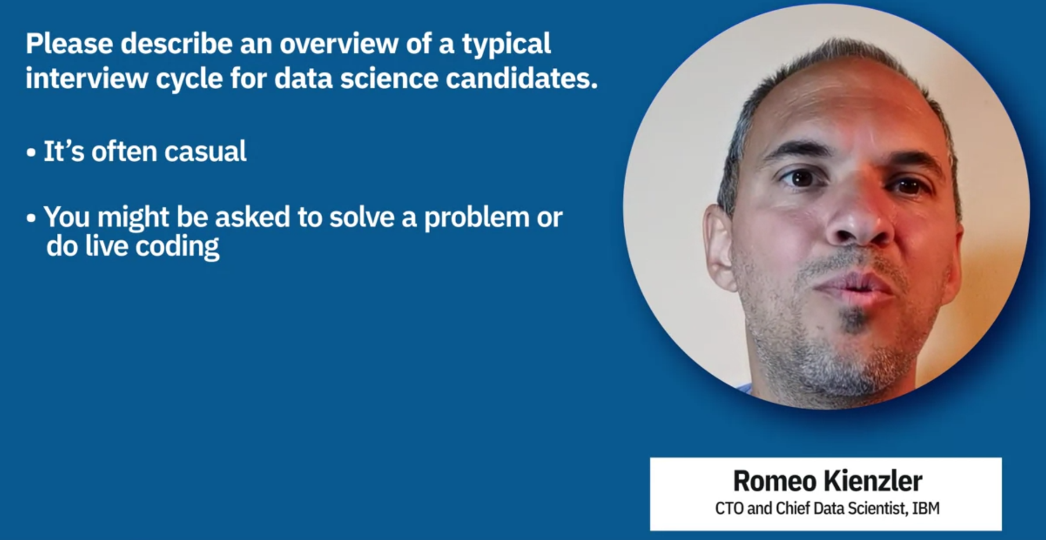

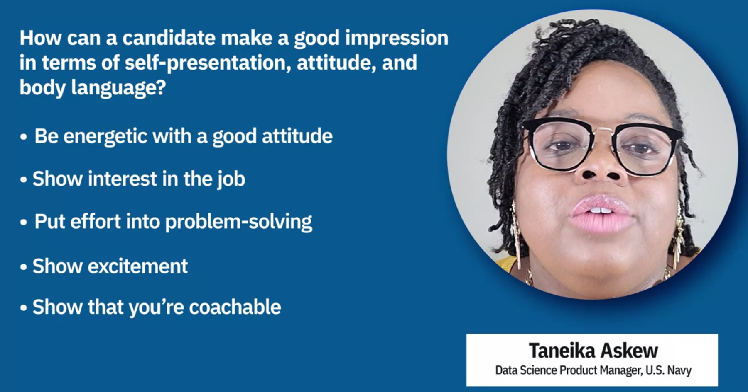

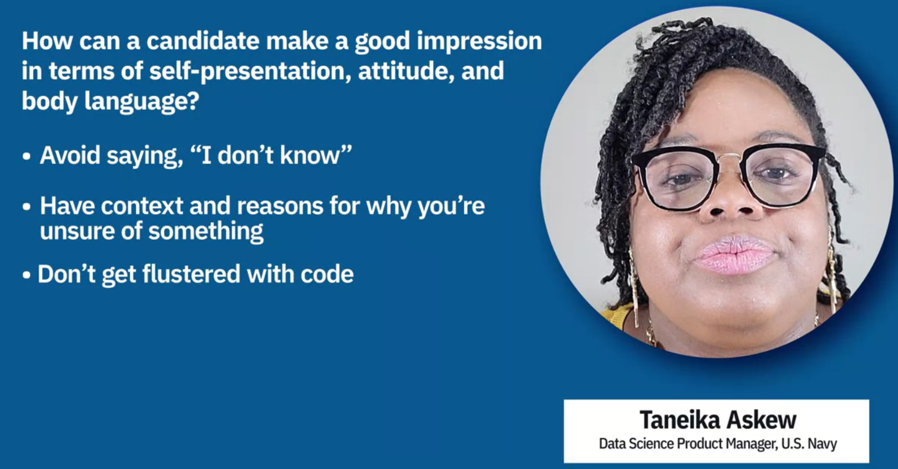

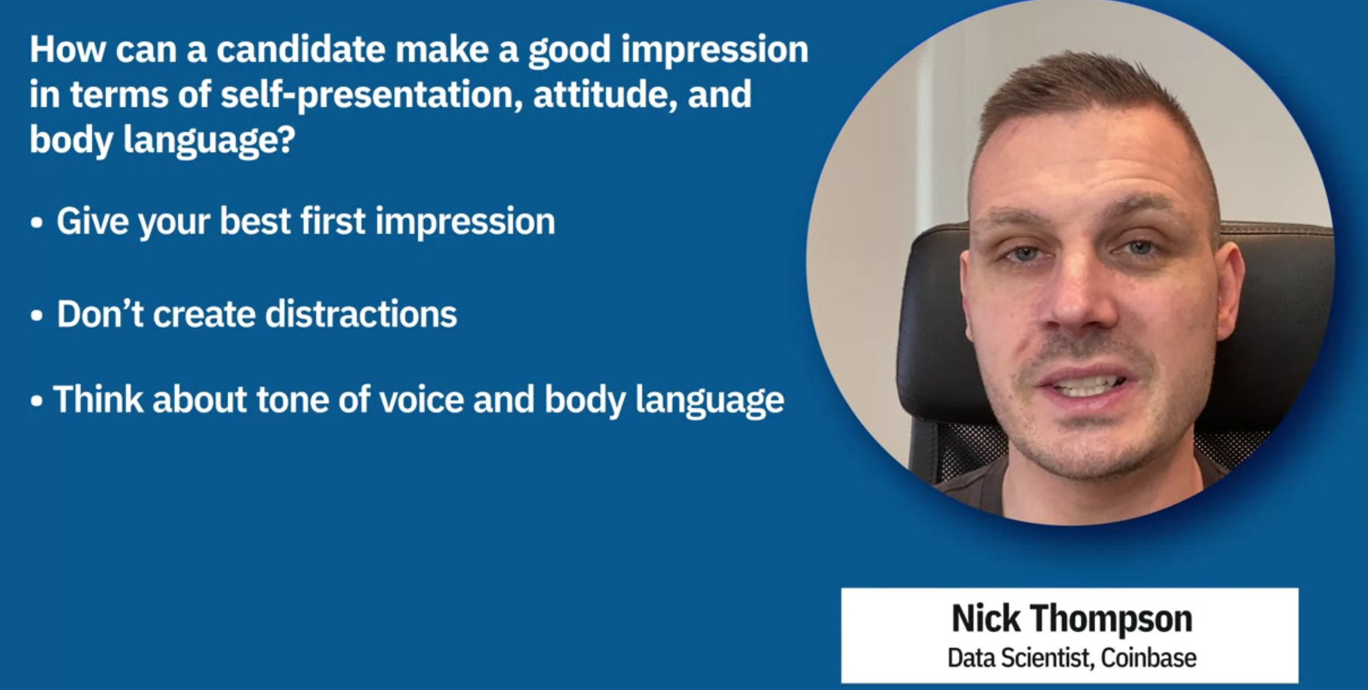

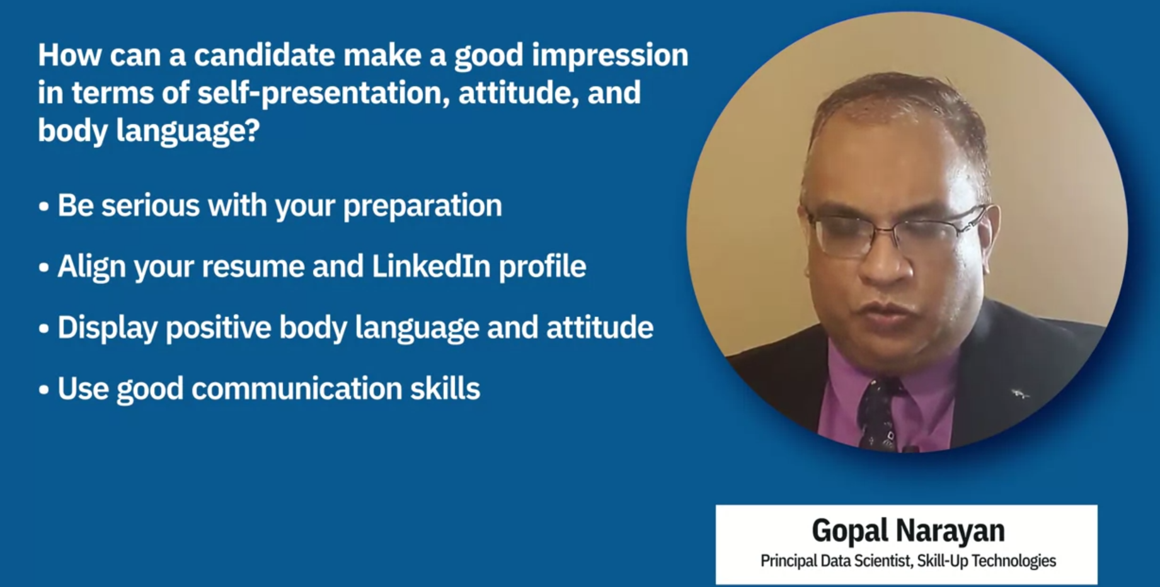

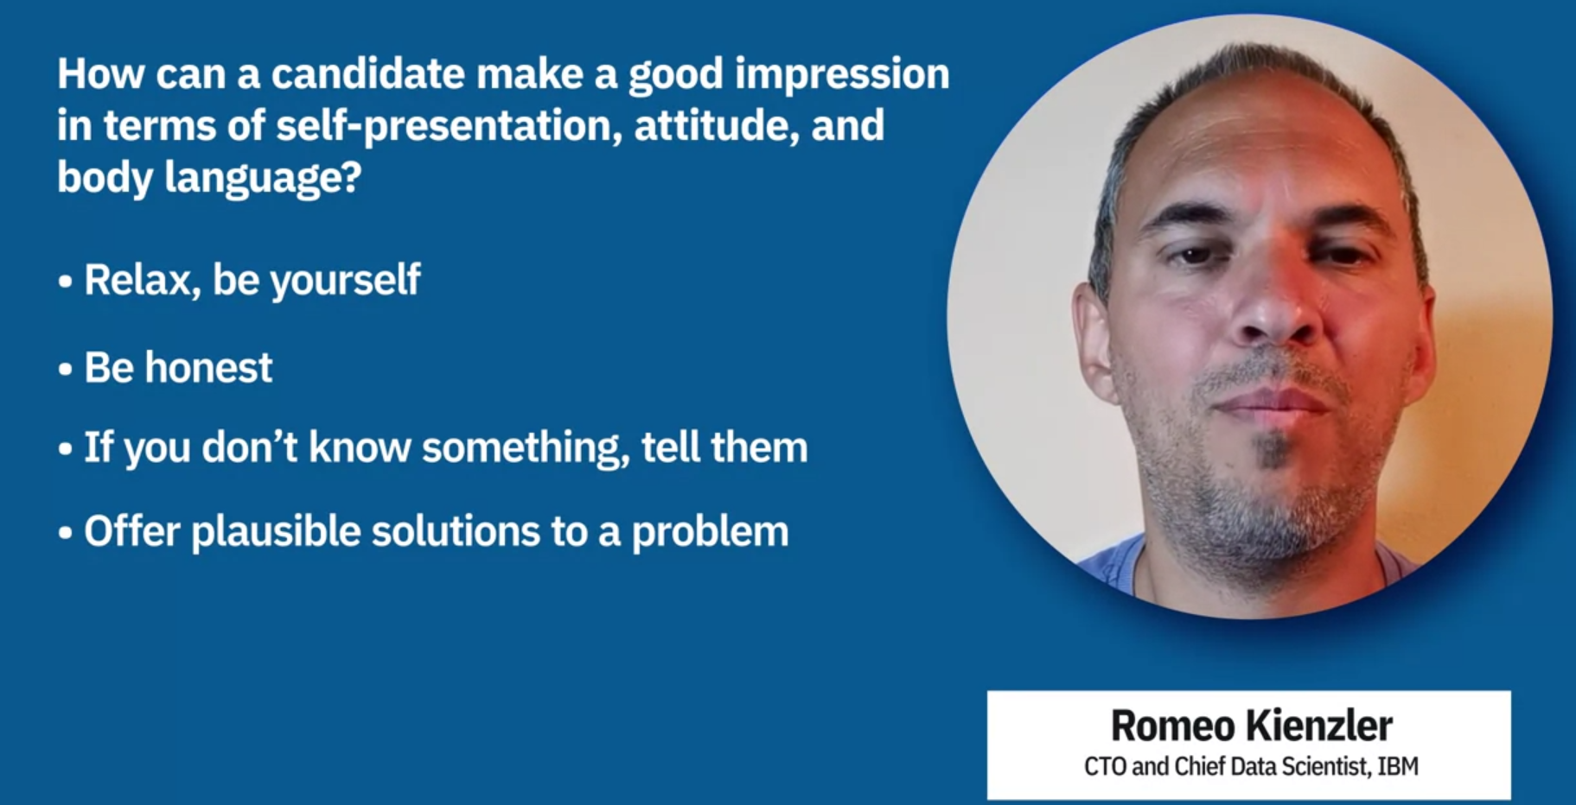

# Unethical Interviewing

As a candidate, you work hard to get an interview. You want nothing more than to cooperate with the hiring company and land that job. However, some interviewers don’t always have your best interest as a priority. It’s important to know what questions are off-limits, both to protect your rights and to understand whether the company you’re interviewing with may not be an ethical and respectful employer.

Be aware that laws and practices about these issues may differ from place to place and in different countries. This reading will cover some of them generally, but always be sure you research your own area and understand the limits that apply to you and your local interviews.

## Personal Information

There are certain categories of personal information that an interviewer should not ask about. Some of them include the following.

* **Race or nationality**. This is strictly illegal in the United States and many other places. Be aware, though, that some interviewers may find indirect ways to get the information, such as asking questions about your name origin or your first language. Some questions about citizenship status and work visas are often allowable because they’re directly related to hiring issues, but it can be tricky. For example, it’s not OK to ask point blank whether a candidate is a citizen, but it can be permissible to ask whether they are legally allowed to work in the country.
* **Gender and sexual preference**. In the United States, it’s illegal to discriminate on this basis, so it’s illegal to ask about it.
* **Marital status and family plans**. In the United States, it’s illegal to ask a candidate their marital status. In any case, this isn’t relevant to most jobs and is usually a way to determine whether the prospective employee will be as dedicated as the company wants. In the case of family plans, it may also be a way to see if female employees may need leave or expensive insurance coverage later. It’s also unethical for an employer to ask for information about your spouse, which is an invasion of privacy.
* **Health history, including family health and family history**. Unless there is some job-related reason to ask about this — and that would be rare — interviewers shouldn’t ask. This is another way for an employer to try to determine whether the candidate may cost them later in terms of insurance rates or sick time, which is unethical.
* **Disability**. In some cases where the job may have specific physical requirements, it might be OK for an interviewer to ask whether the candidate can perform the job. However, employers in the United States must make reasonable accommodations for disabled workers. Relatedly, it’s unethical for an employer to ask whether a candidate has ever been injured on the job or used worker compensation.
* **Age**. It’s permissible to ask candidates whether they are of legal age to do certain jobs where laws define who is eligible. However, more general questions about age when it’s irrelevant to the position are not ethical. Watch out for indirect ways to estimate age, such as asking when you graduated.
* **Legal or arrest record**. It’s unethical to ask candidates about their legal history or arrest record. If an employer has some legitimate reason to know about this, there are official channels they can pursue.
* **Financial history**. Some employers may do a credit check with permission when a candidate is hired, but it’s unethical to ask about this in an interview. Interviewers should not ask about credit, bank accounts, bankruptcy history, and so on. Watch for indirect questions about this, such as questions about home ownership.

Information about other employers and employment

Another important category of information that can be sensitive is information about your previous employers and employment situations. Some of this will be available on your resume, from your references, and so on. Nonetheless, there are some areas where you should be careful with your answers.

* **Company information**. Interviewers should not ask you for internal information about the companies you have worked at in the past. Obviously, they may ask about your projects or tasks there, but anything further is unethical, such as questions about company structure or other projects. Answering these questions may also violate previously signed non-disclosure agreements.
* **Coworkers and managers**. It’s reasonable for prospective employers to check candidate-supplied references. However, interviewers should not ask for inside information about the people you have worked with.
* **Compensation**. Until you get to the point of negotiating a solid offer, be careful about discussing previous salaries. Focus the conversation on what the employer is offering or the general salary for similar positions in your area. Giving information about your past salary may perpetuate unfair compensation practices and lead to an unethical employer offering a lower compensation than the fair market salary.

## Behavior

Employers should generally avoid asking about your personal behaviors, except those that directly impact your prospective role. These questions almost always give an employer more information than they are entitled to and can unfairly affect your candidacy if the employer isn’t ethical.

* **Religion**. In the United States, it’s illegal to ask a candidate about their religious beliefs or affiliation. Watch for indirect questions to find out this information, such as asking about where a candidate worships or spends time on the weekends or the availability of weekend working hours.
* **Testing**. In cases where tests would be legally required or directly relevant, employees may be asked to take certain tests, such as a urine test. However, it’s unethical for an interviewer to ask whether the candidate would be willing and make hiring decisions based on that information. This is also true of lie detector tests, genetic tests, and so on.
* **Use of substances**. Interviewers should not ask about whether candidates smoke, take medications, drink alcohol, or take part in other substance-related behavior on their own time. Again, if drug testing is a requirement for that position, employers can notify a candidate of that and do the testing after a job is accepted, with permission.
* **Political opinions**. It’s inappropriate for an interviewer to engage a candidate about their political views and orientation. Similarly, it’s unethical to question a candidate’s views on unions.
* **Personal appearance**. Some companies have dress standards, and this is acceptable to discuss. However, interviewers should not comment on or ask questions about a candidate’s personal appearance. This can be a way to find out about other topics, like socio-economic status or gender. Moreover, it can indicate a form of discrimination against religious practices or race (as in the case of hairstyles).
* **"Culture fit"**. Some companies are concerned with a candidate’s ability to fit in with the company’s culture. Be careful with questions in this area; often, “culture fit” masks other discrimination as a subtle way of preferring the type of people who already work there (which might, for example, be white, male, younger, or American).

## Conclusion

In nearly every case, employers are ethical and eager to follow the law and treat candidates fairly. However, some will ask the wrong questions, and you should not feel pressured or obliged to answer them. One option is to deflect the question: instead of answering directly, give an answer that’s more closely and appropriately related to the position or your qualifications. If that doesn’t seem possible or if the question is clearly inappropriate, it’s acceptable to simply say you don’t wish to answer and move on. If this makes you a less desirable candidate for that position, consider that you may not want to work for a company that exhibits questionable policies anyway.

